SCHOOL OF COMPUTER SCIENCE AND ARTIFICIAL INTELLIGENCE |  |  |  |  | DEPARTMENT OF COMPUTER SCIENCE ENGINEERING
Program Name: B. Tech |  |  |  | Assignment Type: Lab |  |  | Academic Year:2025-2026
Course Coordinator Name |  |  |  | Dr. Rishabh Mittal
Instructor(s) Name |  |  |  | Mr. S Naresh Kumar  Ms. B. Swathi  Dr. Sasanko Shekhar Gantayat  Mr. Md Sallauddin  Dr. Mathivanan  Mr. Y Srikanth  Ms. N Shilpa  Dr. Rishabh Mittal (Coordinator)  Dr. R. Prashant Kumar  Mr. Ankushavali MD  Mr. B Viswanath  Ms. Sujitha Reddy  Ms. A. Anitha  Ms. M.Madhuri  Ms. Katherashala Swetha  Ms. Velpula sumalatha  Mr. Bingi Raju
CourseCode |  |  | 23CS002PC304 | Course Title |  | AI Assisted Coding
Year/Sem |  |  | III/II | Regulation |  | R23
Date and Day  of Assignment |  |  | Week3 – Wednusday | Time(s) |  | 23CSBTB01 To 23CSBTB52
Duration |  |  | 2 Hours | Applicable to  Batches |  | All batches
Assignment Number:8.3(Present assignment number)/24(Total number of assignments)
 | Q.No. | Question |  |  |  |  |  | ExpectedTime  to complete
 | 1 | Lab 8: Test-Driven Development with AI – Generating and Working with Test Cases  Lab Objectives  • Introduce TDD using AI  • Generate test cases before implementation  • Emphasize testing and validation  • Encourage clean, reliable code  Lab Outcomes  Students will be able to:  • Write AI-generated test cases  • Implement code using test-first approach  • Validate using unittest  • Analyze test coverage  • Compare AI vs manual tests  Task 1: Email Validation using TDD  Scenario  You are developing a user registration system that requires reliable email input validation.  Requirements  • Must contain @ and . characters  • Must not start or end with special characters  • Should not allow multiple @ symbols  • AI should generate test cases covering valid and invalid email formats  • Implement is_valid_email(email) to pass all AI-generated test cases  Expected Output  • Python function for email validation  • All AI-generated test cases pass successfully  • Invalid email formats are correctly rejected  • Valid email formats return True  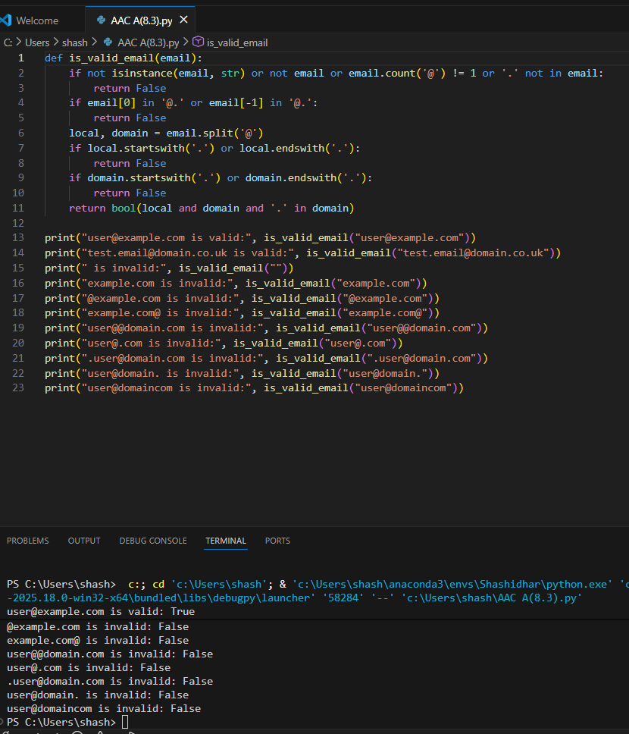  Task 2: Grade Assignment using Loops  Scenario  You are building an automated grading system for an online examination platform.  Requirements  • AI should generate test cases for assign_grade(score) where:  – 90–100 → A  – 80–89 → B  – 70–79 → C  – 60–69 → D  – Below 60 → F  • Include boundary values (60, 70, 80, 90)  • Include invalid inputs such as -5, 105, "eighty"  • Implement the function using a test-driven approach  Expected Output  • Grade assignment function implemented in Python  • Boundary values handled correctly  • Invalid inputs handled gracefully  • All AI-generated test cases pass  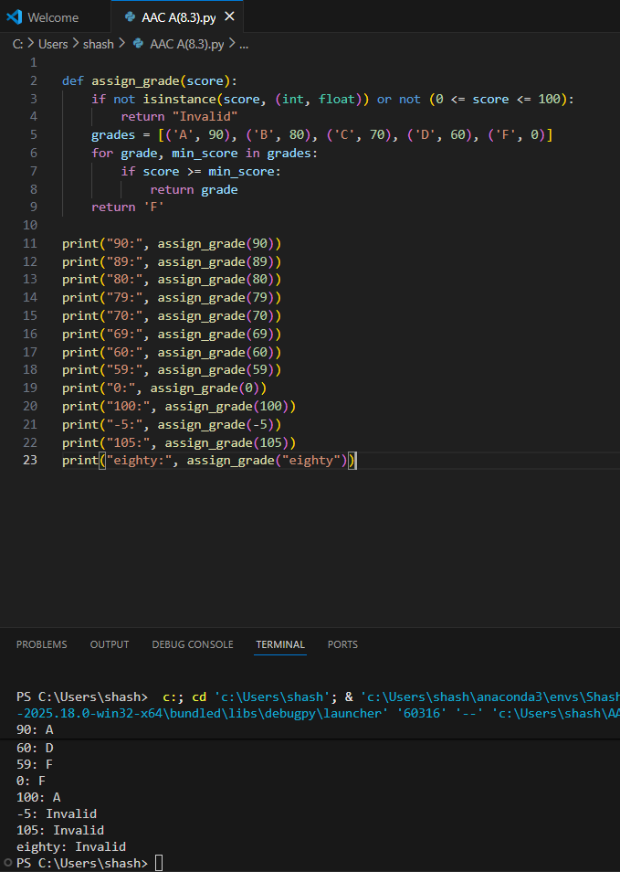  Task 3: Sentence Palindrome Checker  Scenario  You are developing a text-processing utility to analyze sentences.  Requirements  • AI should generate test cases for is_sentence_palindrome(sentence)  • Ignore case, spaces, and punctuation  • Test both palindromic and non-palindromic sentences  • Example:  – "A man a plan a canal Panama" → True  Expected Output  • Function correctly identifies sentence palindromes  • Case and punctuation are ignored  • Returns True or False accurately  • All AI-generated test cases pass  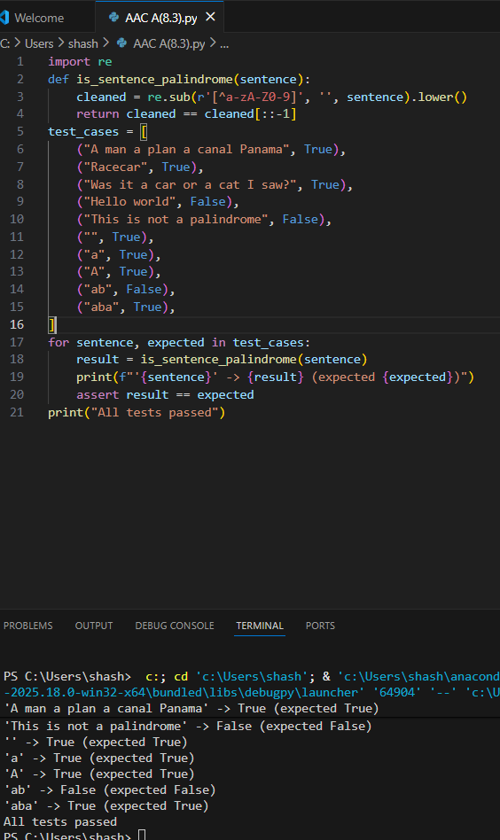  Task 4: ShoppingCart Class  Scenario  You are designing a basic shopping cart module for an e-commerce application.  Requirements  • AI should generate test cases for the ShoppingCart class  • Class must include the following methods:  – add_item(name, price)  – remove_item(name)  – total_cost()  • Validate correct addition, removal, and cost calculation  • Handle empty cart scenarios  Expected Output  • Fully implemented ShoppingCart class  • All methods pass AI-generated test cases  • Total cost is calculated accurately  • Items are added and removed correctly  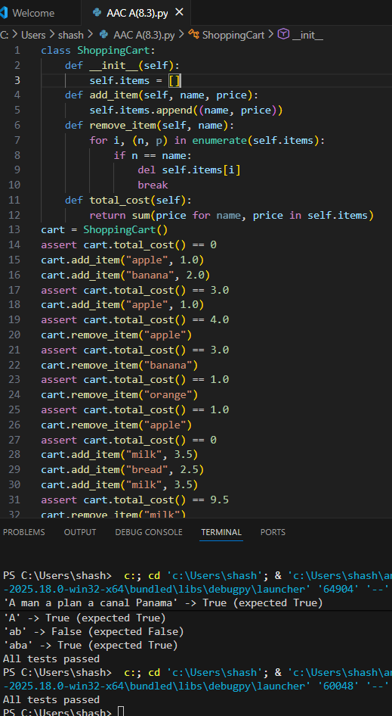  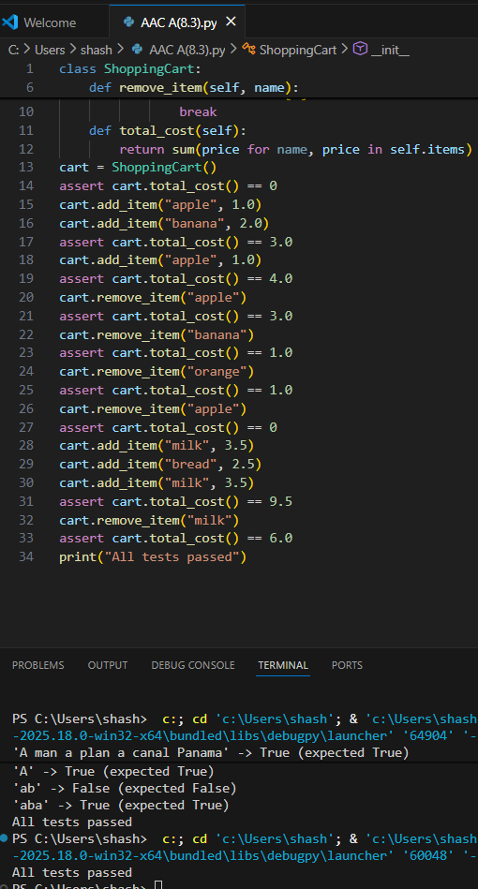  Task 5: Date Format Conversion  Scenario  You are creating a utility function to convert date formats for reports.  Requirements  • AI should generate test cases for convert_date_format(date_str)  • Input format must be "YYYY-MM-DD"  • Output format must be "DD-MM-YYYY"  • Example:  – "2023-10-15" → "15-10-2023"  Expected Output  • Date conversion function implemented in Python  • Correct format conversion for all valid inputs  • All AI-generated test cases pass successfully  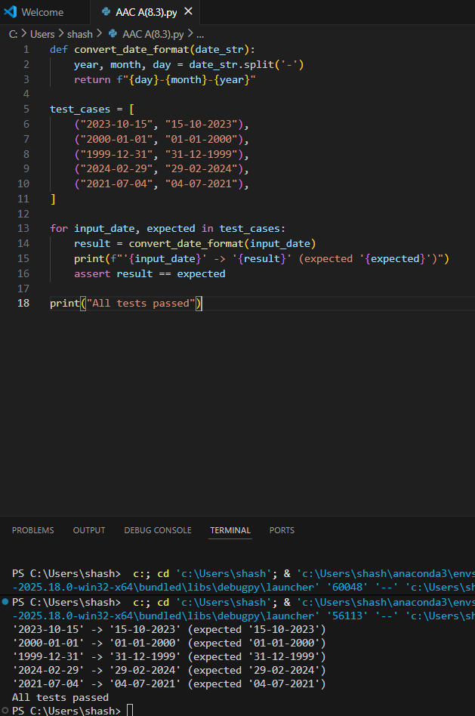  Note: Report should be submitted as a word document for all tasks in a single document with prompts, comments & code explanation, and output and if required, screenshots. |  |  |  |  |  | Week4 - Wednesday

